Derivational Morpheme

🔧 What is a Derivational Morpheme?
# Source: Chatgpt (GPT-4-turbo) at [7/24/2025]
A derivational morpheme is a bound morpheme that is added to a word to create a new word — often changing its meaning or grammatical category (part of speech).

📘 Definition:
# Source: Chatgpt (GPT-4-turbo) at [7/24/2025]
A derivational morpheme forms a new word by changing either the meaning of the base word or its part of speech (e.g., from verb to noun, noun to adjective, etc.).

🧾 Examples of Derivational Morphemes:
# Source: Chatgpt (GPT-4-turbo) at [7/24/2025]
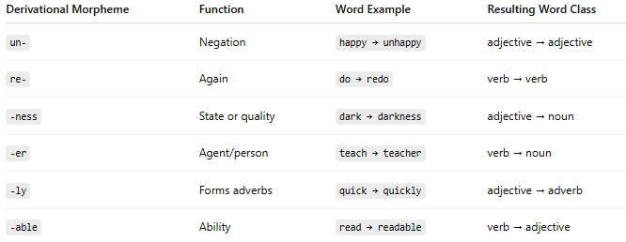
Derivational Morpheme | Function | Word Example | Resulting Word Class
un- | Negation | happy → unhappy | adjective → adjective
re- | Again | do → redo | verb → verb
-ness | State or quality | dark → darkness | adjective → noun
-er | Agent/person | teach → teacher | verb → noun
-ly | Forms adverbs | quick → quickly | adjective → adverb
-able | Ability | read → readable | verb → adjective

✅ Key Features:
# Source: Chatgpt (GPT-4-turbo) at [7/24/2025]
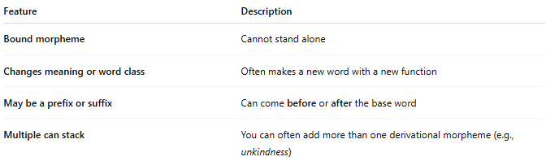
Feature | Description
Bound morpheme | Cannot stand alone
Changes meaning or word class | Often makes a new word with a new function
May be a prefix or suffix | Can come before or after the base word
Multiple can stack | You can often add more than one derivational morpheme (e.g., unkindness)

📊 Derivational vs. Inflectional Morphemes
# Source: Chatgpt (GPT-4-turbo) at [7/24/2025]
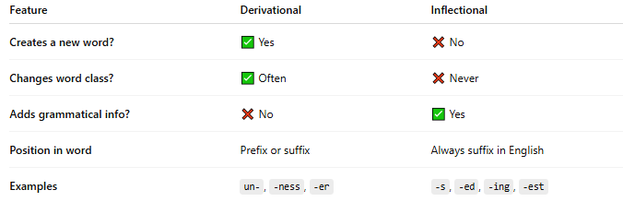
Feature | Derivational | Inflectional
Creates a new word? | ✅ Yes | ❌ No
Changes word class? | ✅ Often | ❌ Never
Adds grammatical info? | ❌ No | ✅ Yes
Position in word | Prefix or suffix | Always suffix in English
Examples | un-, -ness, -er | -s, -ed, -ing, -est

🧠 Example Breakdown:
# Source: Chatgpt (GPT-4-turbo) at [7/24/2025]
Word: unhappiness
- un- → derivational prefix (negation)
- happy → free morpheme (base word)
- -ness → derivational suffix (state of being)
➡️ unhappiness = the state of not being happy
➡️ Changed word meaning and class: adjective → noun

✅ Summary:
# Source: Chatgpt (GPT-4-turbo) at [7/24/2025]
A derivational morpheme helps create new words by changing meaning, function, or word category.
It plays a key role in building vocabulary and expression in a language.

